ABC organization

Zocdoc: Adding 5 Doctors to the Portal
[Version 1]

User Acceptance Test Plan

Contents Page

Table of Contents
- Objective
- Scope
- Participants
- Testing Environment
- Test Scenarios and Acceptance Criteria
  - 5.1 Profile Creation
  - 5.2 Profile Completeness
  - 5.3 Appointment Scheduling
  - 5.4 Availability Display
  - 5.5 Patient Reviews
  - 5.6 Search Functionality
- Test Schedule
- Defect Management
- Sign-off Criteria
- Reporting

Document Version History
Version | Date | Changes | Author(s) | Approver(s)
1.0 |  | Original plan.

- Objective

To validate that the new doctors' profiles are correctly integrated into the Zocdoc portal and meet business requirements and user needs before the official launch.

2. Scope
- Testing of the profile creation process for each of the five new doctors.
- Functionality of appointment scheduling.
- Patient review and rating system.
- Search functionality to ensure new doctors are discoverable.

3. Participants
- UAT Testers: Selected users, including patients and administrative staff.
- Business Analysts: To monitor the testing process and gather feedback.
- Development Team: To address any issues that arise during testing.

4. Testing Environment
- Use a staging environment that mirrors the production environment to conduct tests without affecting live users.

5. Test Scenarios and Acceptance Criteria

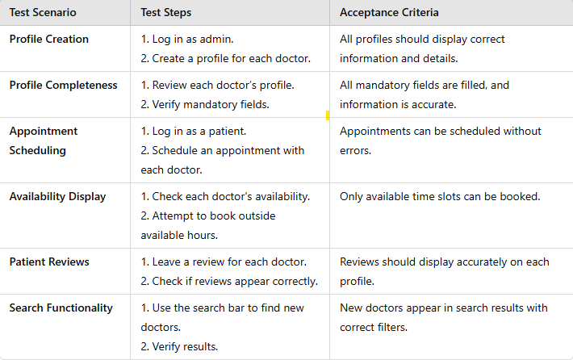
6. Test Schedule
- Preparation: [Date] - Ensure all test accounts and environments are ready.
- Testing Window: [Start Date] to [End Date] - Execute all test scenarios.
- Review and Feedback: [Date] - Gather feedback and address issues.

7. Defect Management
- Any issues found during testing will be logged in the project management tool.
- Severity and priority will be assigned for each defect.
- The development team will address critical issues before the launch.

8. Sign-off Criteria
- All test scenarios must pass without critical defects.
- Feedback from testers must be reviewed and addressed.
- Final approval must be obtained from stakeholders before proceeding to launch.

9. Reporting
- A summary report will be generated at the end of the testing phase, detailing:
  - Passed and failed test cases.
  - Summary of defects and their status.
  - Tester feedback and recommendations.

